**Deploying Amazon RDS Multi-AZ and Read Replica, Simulate Failover**

**==================================**

1. **Creating an EC2 Instance**

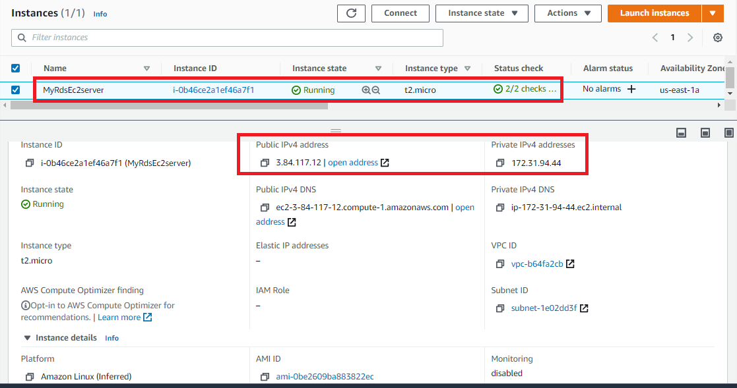

Fig 1. Ec2 Dashboard

1. **Create a Security Group for RDS instance**

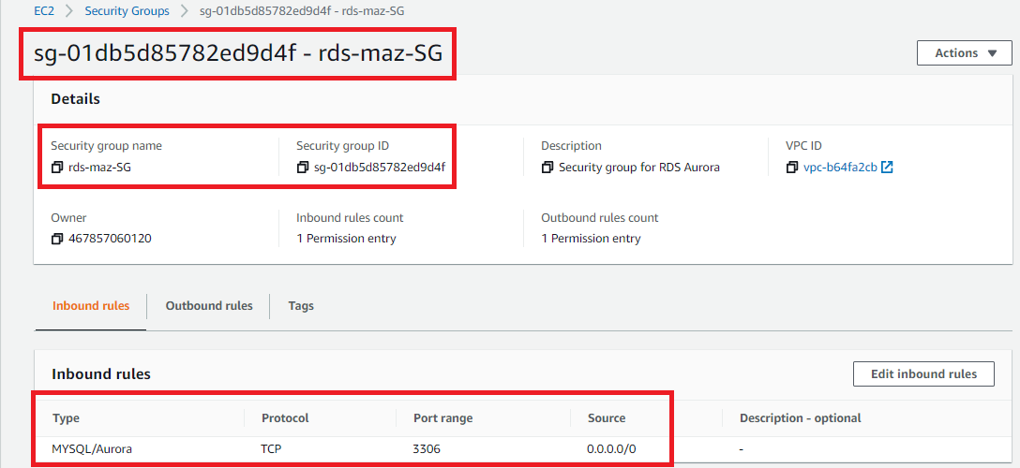

Fig 2. Security group

1. **Create an Amazon Aurora database with Multi-AZ enabled**

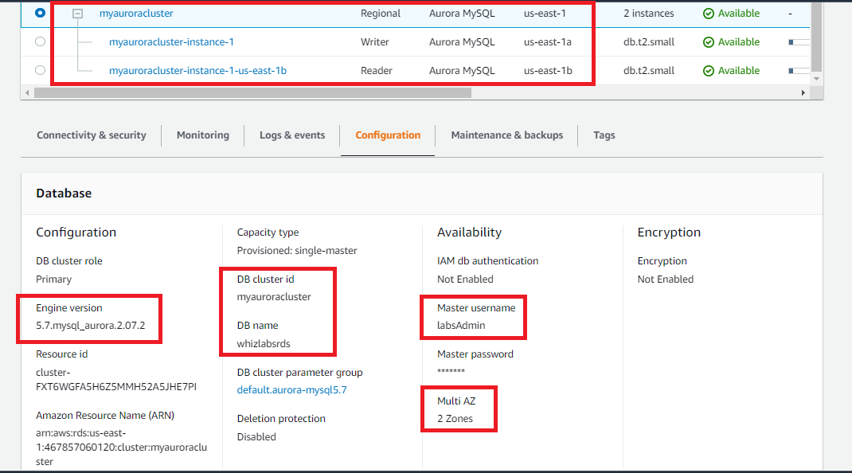

Fig 3. RDS Dashboard (Configuration)

1. **Connecting the EC2 Server to RDS:**

**NOTE: Edited the inbound rule source IP of RDS instance security group to private IP of the RDS ec2 instance with CIDR block /32.**

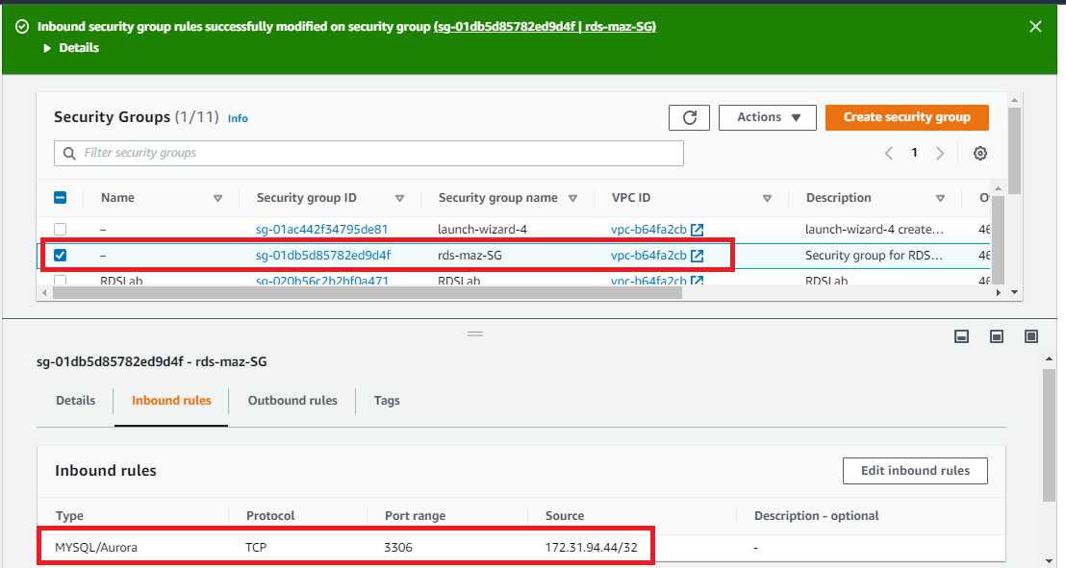

Fig 4. Edited security group for writer

1. **Connecting to the Aurora (MySQL) database on RDS**

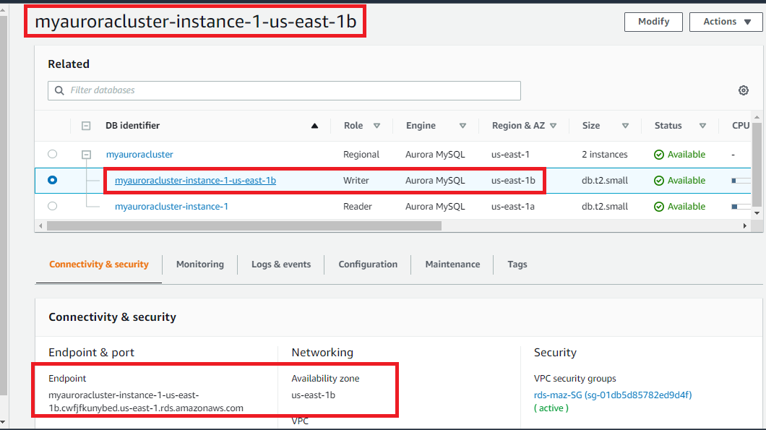

Fig 5. RDS Dashboard for Writer

1. **Execute Database Operations via SSH(Writer)**

**mysql -hmyauroracluster-instance-1-us-east-1b.cwfjfkunybed.us-east-1.rds.amazonaws.com -ulabsAdmin -plabs1234**

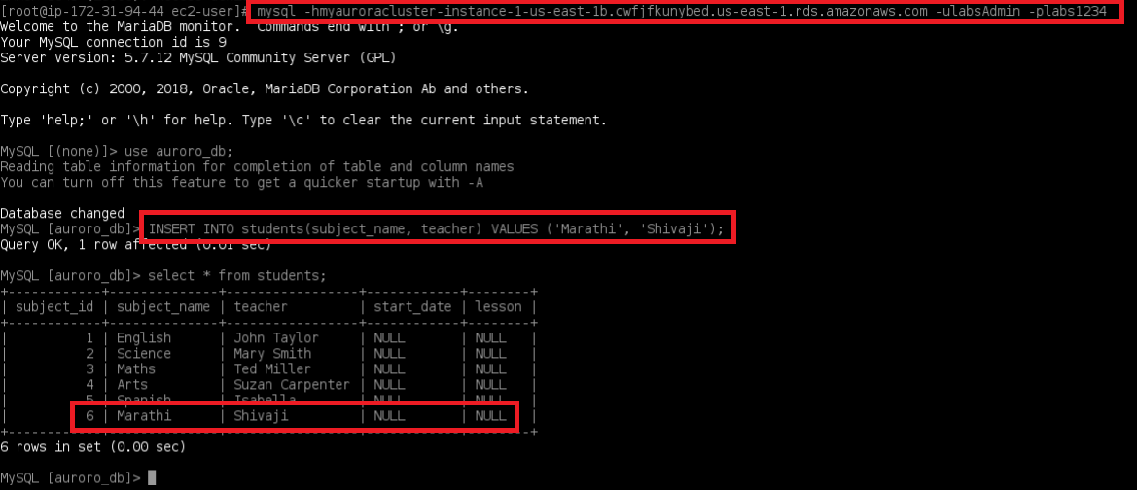

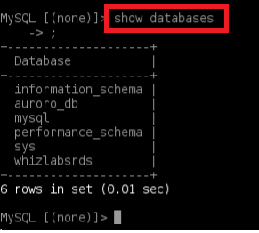

Fig 6.1 Query execution on Writer

**mysql -hmyauroracluster-instance-1.cwfjfkunybed.us-east-1.rds.amazonaws.com -ulabsAdmin -plabs1234**

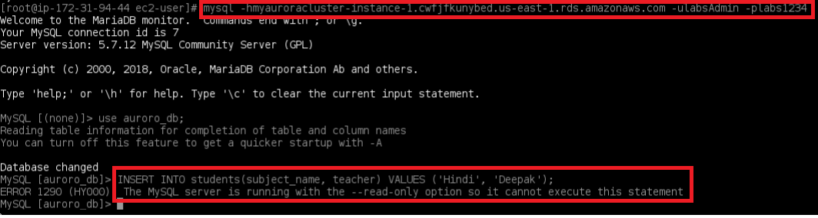

Fig 6.2 Query execution on Reader

1. **Forcing a Failover to Test Multi-AZ**

**NOTE: After failover of us-east-1b it changed from writer to reader**

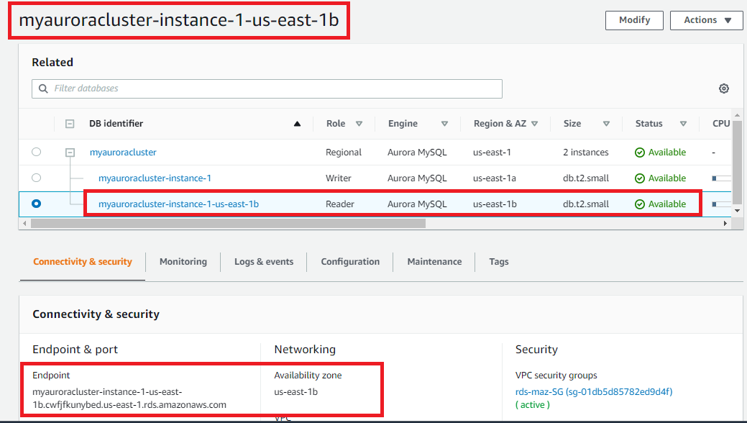

Fig 7. After failover dashboard

1. **After failover Database Operations via SSH(Writer)**

**mysql -hmyauroracluster-instance-1.cwfjfkunybed.us-east-1.rds.amazonaws.com -ulabsAdmin -plabs1234**

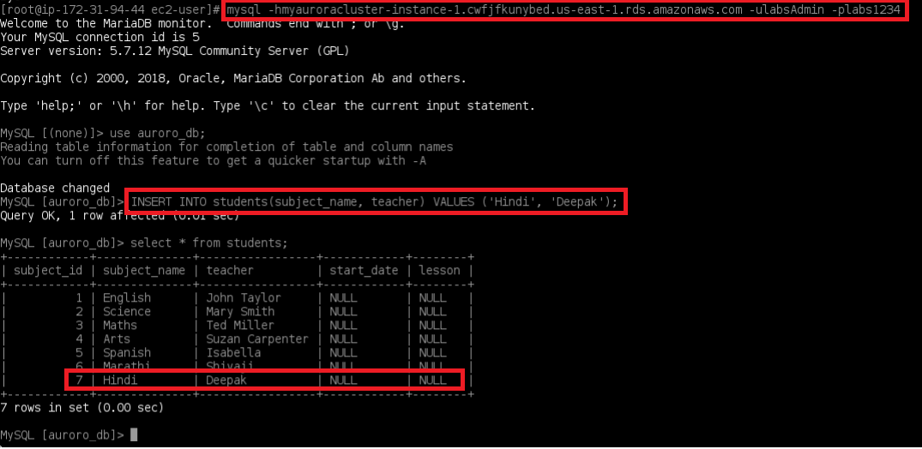

Fig 8.1 Query execution on Writer

**mysql -hmyauroracluster-instance-1-us-east-1b.cwfjfkunybed.us-east-1.rds.amazonaws.com -ulabsAdmin -plabs1234**

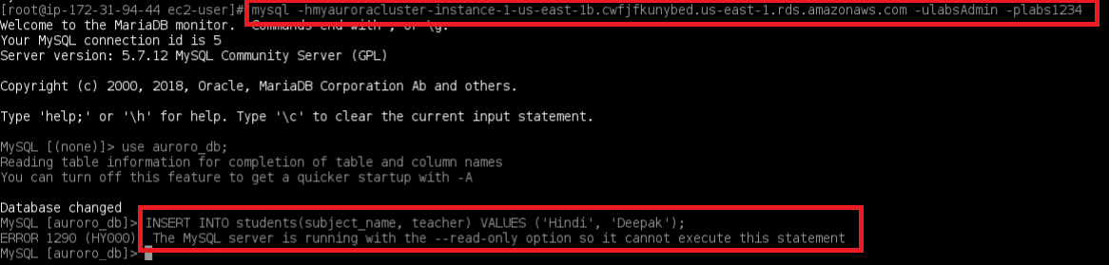

Fig 8.2 Query execution on Reader